
Bandırma Onyedi Eylul University
Faculty of Engineering and Natural Sciences
Computer Engineering Department
BLM2225 Internet-Based Programming
Final Project Report (Sample Template)
- Project Name: (Must be included in the project)
Cafe Web System.
- Introduction: (Must be included in the project)
This report covers the planning, analysis, design, implementation, and testing of a web-based system developed for a cafe business, in accordance with the software lifecycle. The project aimed to create a system where users could browse and order products, leave reviews, and dynamically update content via an administration panel.
- Software Development Process: (Must be included in the project)
This project was implemented based on the "Incremental Software Development Model." In this model, the system is divided into functional parts, and each part is integrated into the system through successively developed versions. Each increment is planned and tested to complete a module or core function. This approach has resulted in a flexible and controllable development process.
- Planning Phase: (Must be included in the project)
The following steps were taken during the project planning process:
- Goal Setting: To establish a digital presence for the cafe business and launch an online ordering system.
- Technology Selection:
- Backend: PHP
- Frontend: HTML, CSS, JavaScript
- Database: MySQL
- Team Assignment:
  - Team Leader: ..
  - Backend Developer: ..
  - Frontend Developer : ..
  - Test Engineer: ..
The development process was structured as follows: first, the basic pages and functions were created, then the interface was completed, and finally, the system was tested.
4. Analysis Phase (Must be included in the project)
a) Functional Requirements:
- User registration/login processes
- Product listing and detail display
- Creating an order
- Don't comment
- Content management via the admin panel
- Contact form and map integration
b) Database Requirements: (Must be included in the project)
The following tables were designed as part of the project:
- User -> User ID (PK), First Name, Last Name, Email, Password, TotalNumberOfReviews, DiscountPercentage
- Product -> Product ID (PK), Name, Category ID (FK), Price, Description, Stock Status, Date Added
- Category -> CategoryID (PK), Name
- Comment -> Comment ID (PK), Product ID (FK), User ID (FK), Text, Rating, Date
- Service -> Service ID (PK), Name, Description
- Order -> OrderID (PK), UserID (FK), Date, Total Amount
- OrderDetails -> OrderDetailID (PK), OrderID (FK), ProductID (FK), Quantity, Price
5. Design Phase: (Must be included in the project)
a) Database Design: (ER diagram should be included)
A local database was designed. Database management was provided via MySQL.
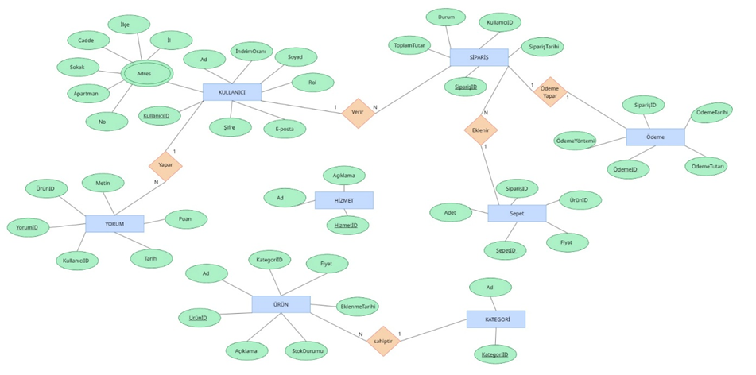
b) User Interface Design: (The PHP, HTML, CSS, and Javascript code for each screenshot should be added to the report, immediately below the screenshot itself.)
- Pages: Home, About Us, Products, Services, References, Orders, Contact, Admin Panel
- CSS-based responsive design
- User experience prioritized, minimalist and aesthetic design.
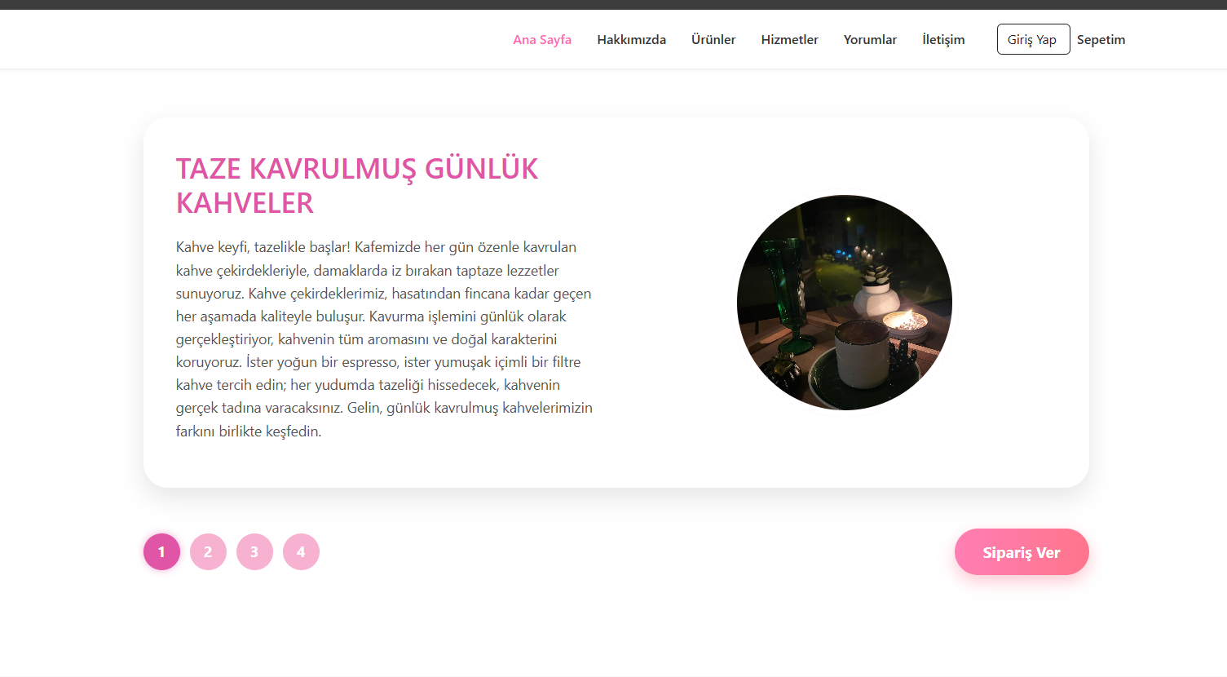
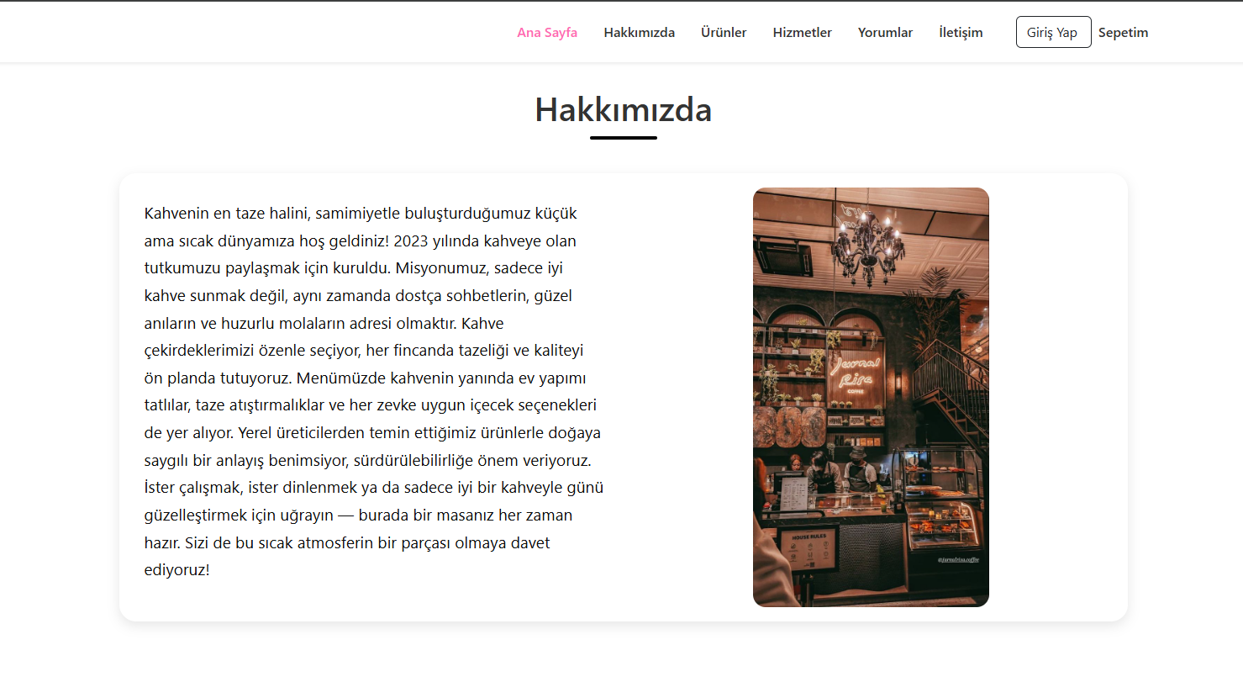
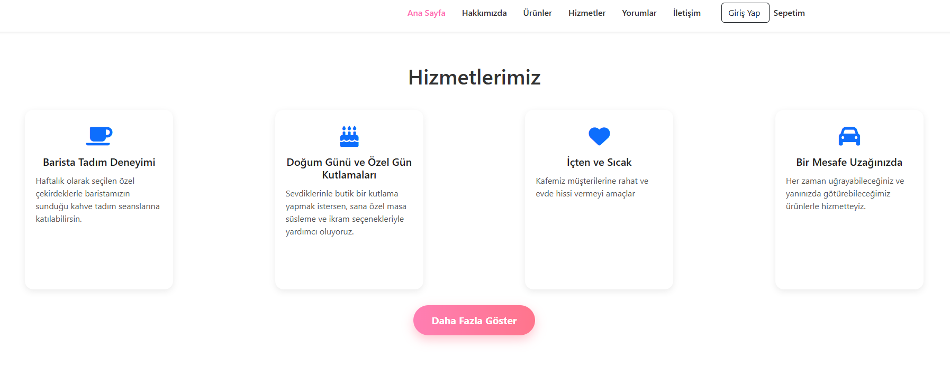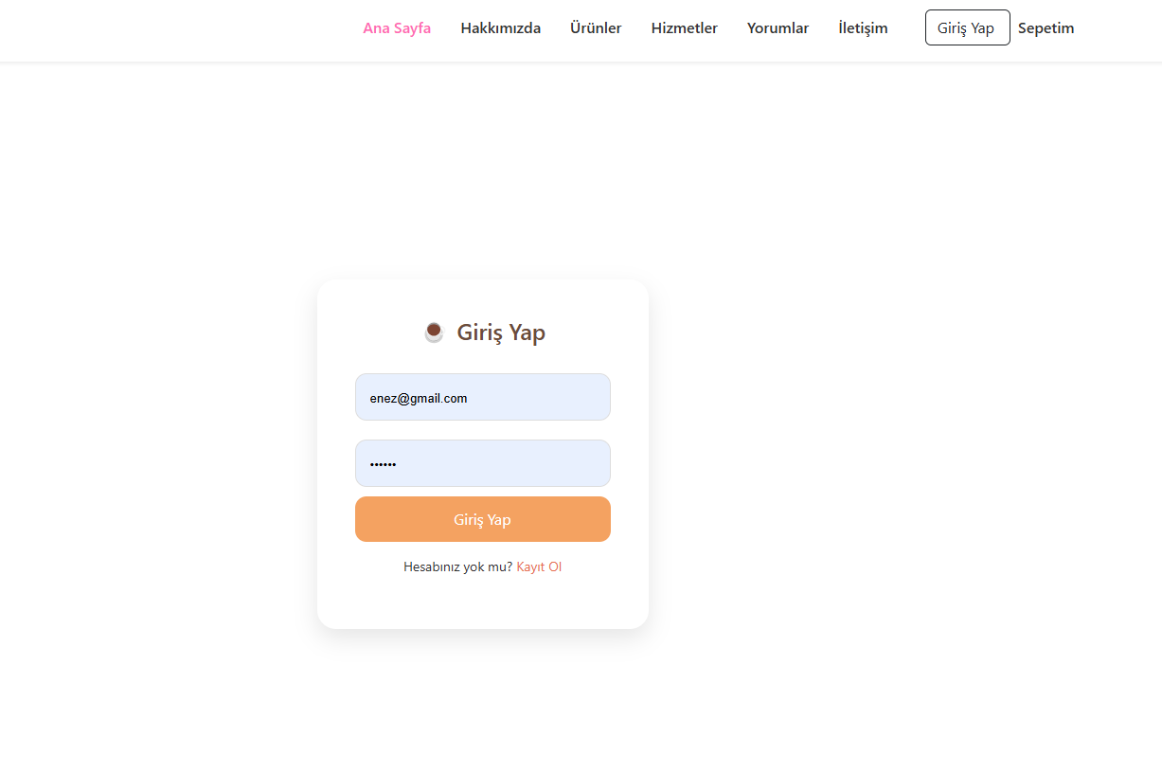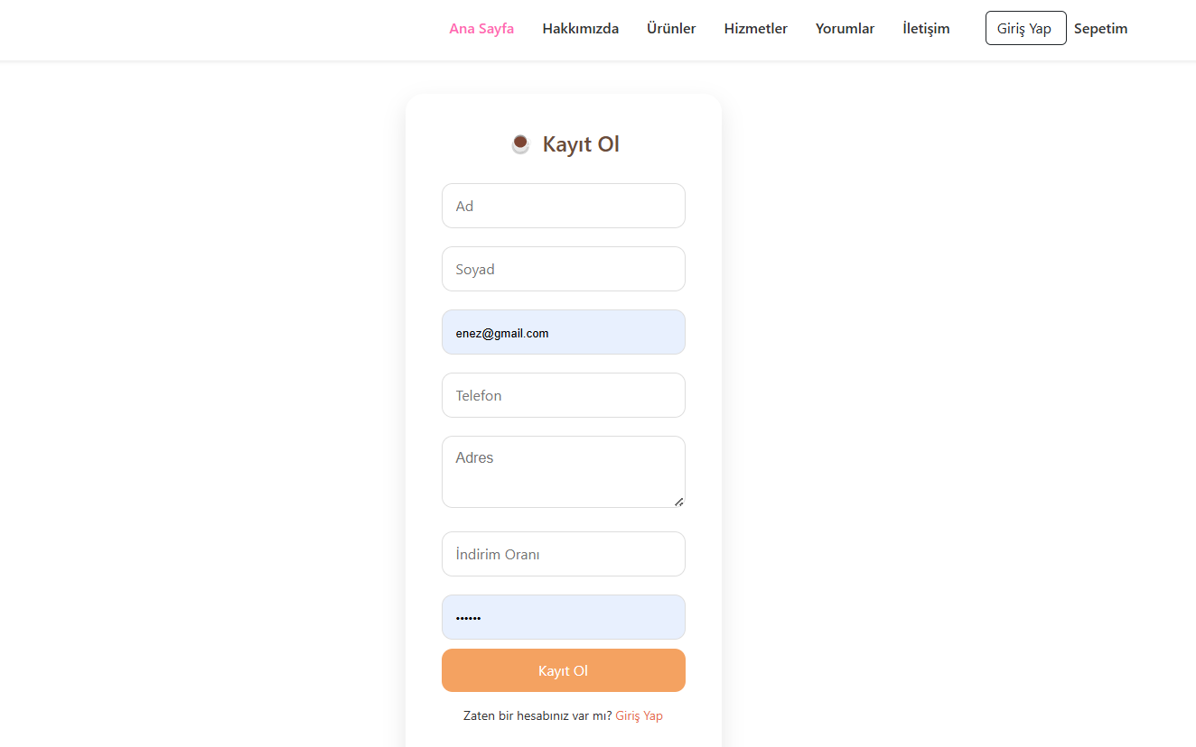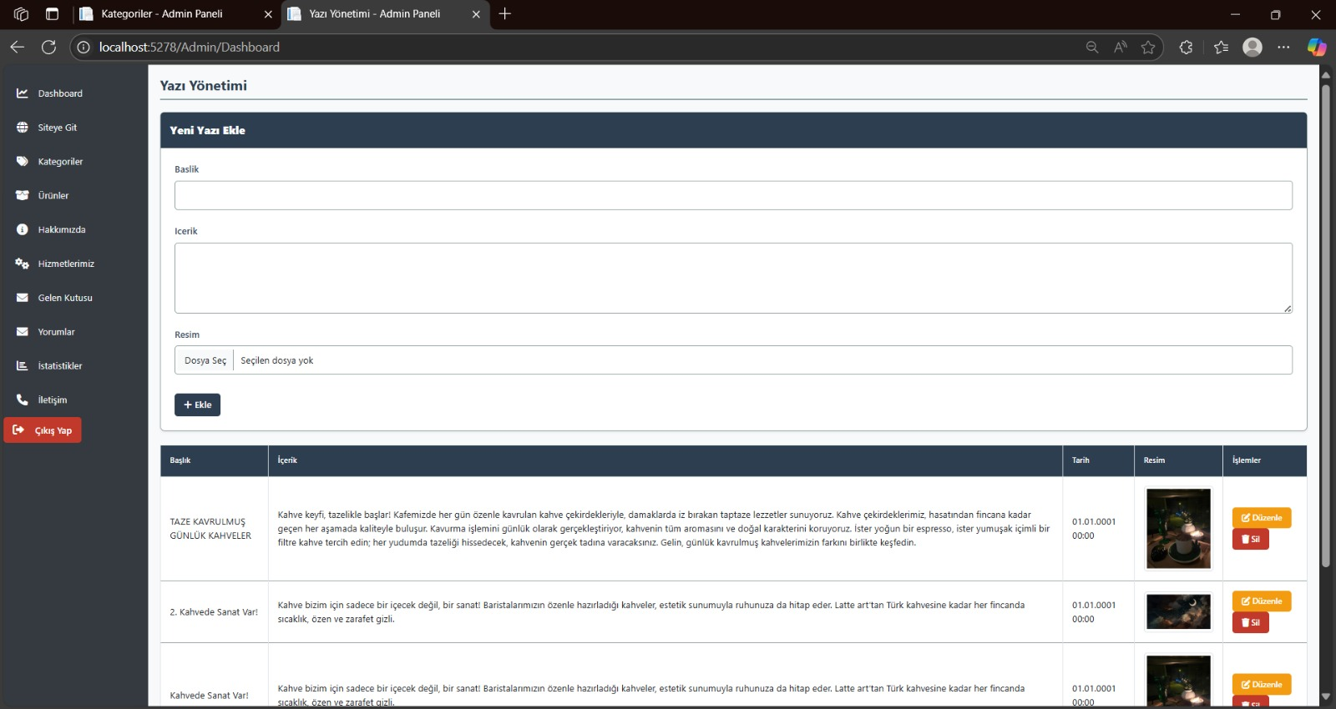
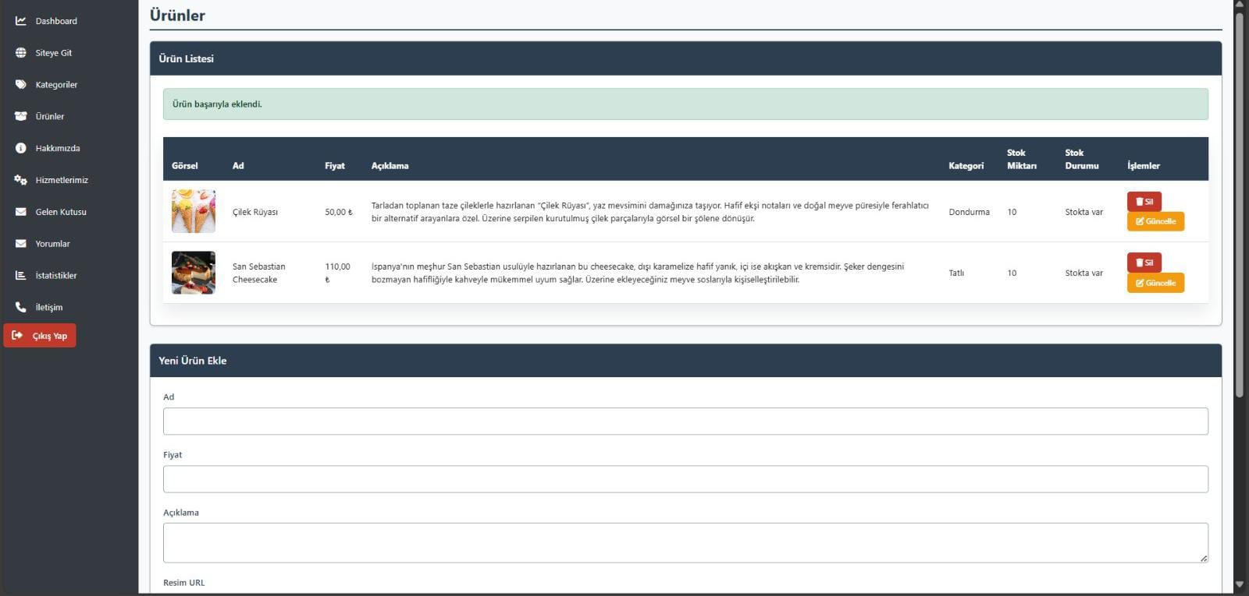
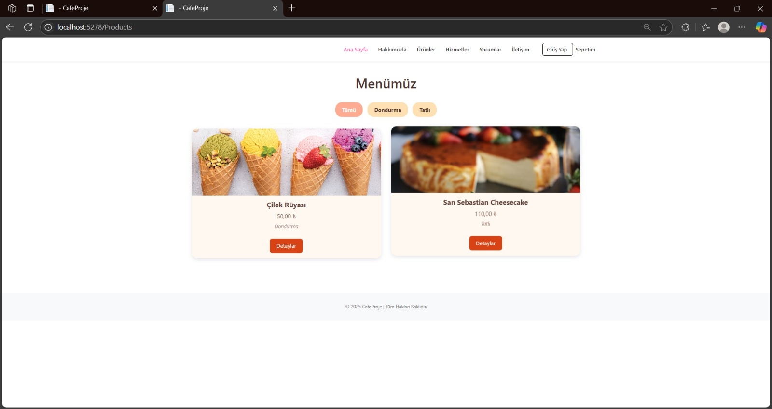
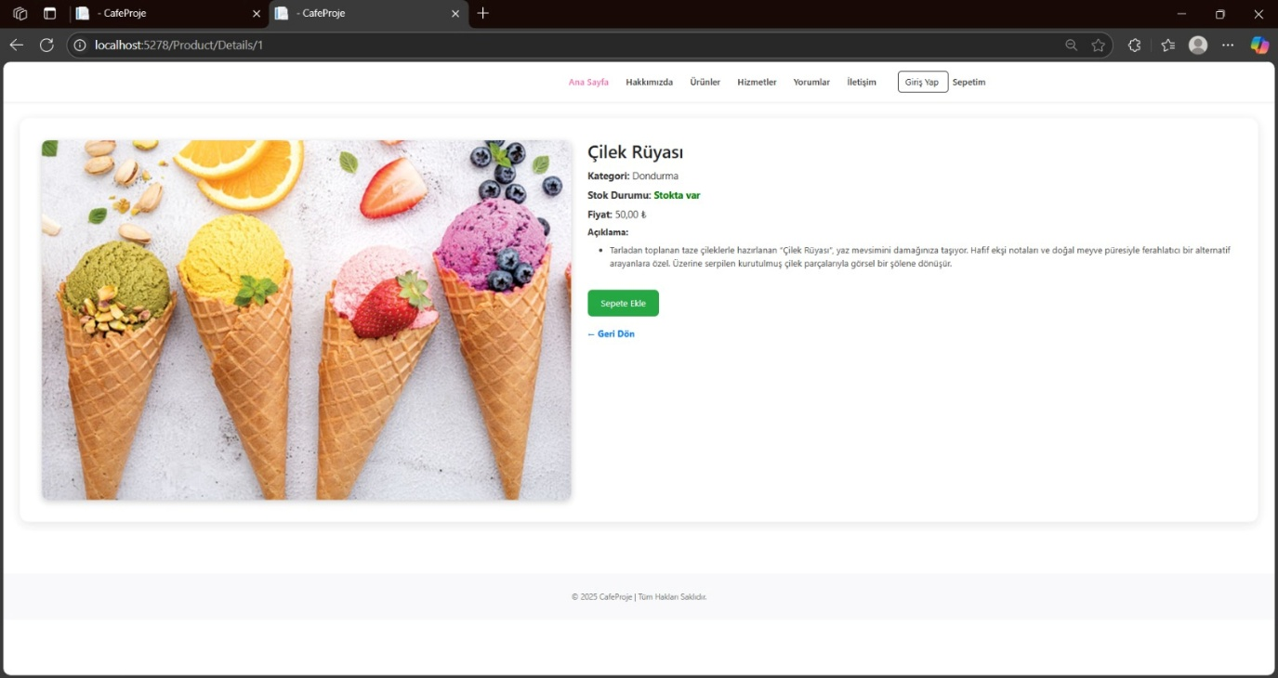
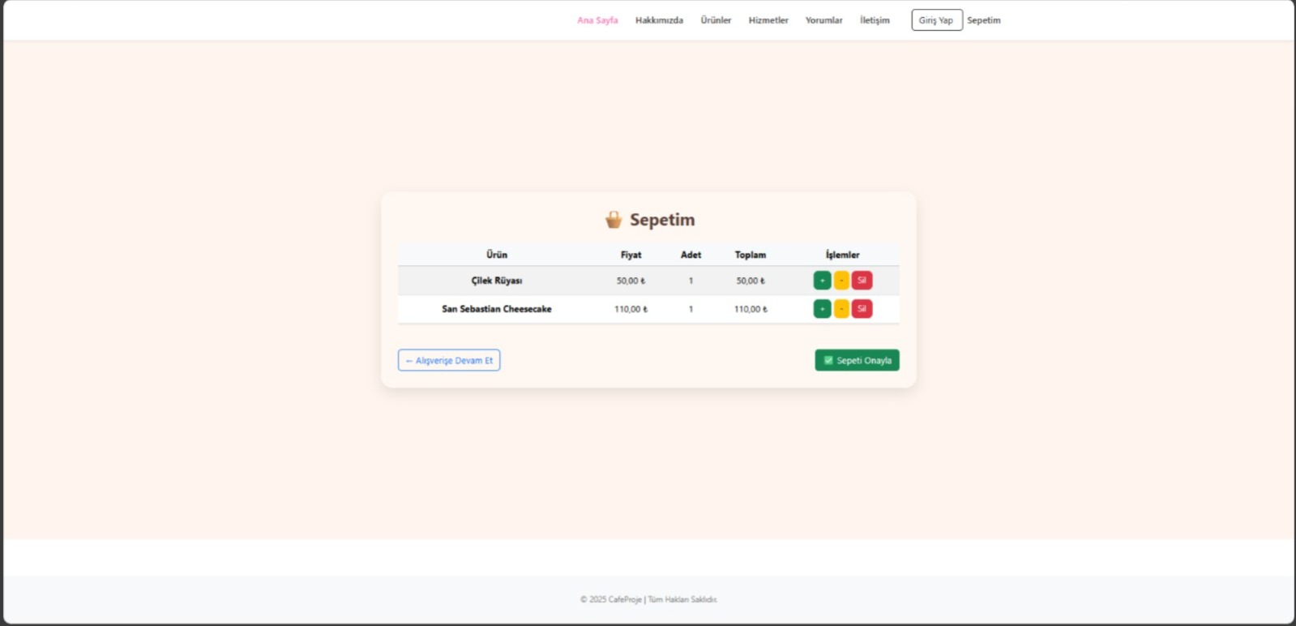
6. Implementation Phase (PHP/Mysql/HTML/CSS/Javascript code for each step in the implementation phase should be included in the report in a readable format)
Within the incremental model, development progressed through the following stages:
- Initial Upgrade: Core Functions and Backend
- Database infrastructure has been established.
- User registration/login systems have been improved.
- Product/Category models and CRUD operations were performed.

- Second Increase: Admin Panel
- Product, service and category management
- Comments, communication responses, and management.
- General statistics table (number of orders, revenue, number of products, etc.)

- Third Enhancement: Order and Review System
- Shopping cart and order creation infrastructure
- Order history
- User-based review and rating system

- Fourth Enhancement: Frontend Completion
- Completion of responsive interfaces.
- Complete integration of all pages.
- Navigation and user experience improvements
7. Testing and Maintenance Phase: (Must be part of the project)
Tests Performed:
- Unit Tests: Basic functions such as login, registration, and product addition were tested.
- Integration Tests: Order-user relationship and admin operations were tested.
- Acceptance Tests: The compatibility of all modules was observed.
- Manual User Testing: User experience tests were conducted.
Problems encountered:
- Error occurring when updating categories in the admin panel → fixed.
- Missing stock control in order details → control added.
8. Conclusion and Evaluation: (Must be included in the project)
The developed system is structured to meet all the digital needs of a cafe business. It offers a functional, user-friendly, and modern interface for both users and management. Thanks to the incremental development model, the project has been gradually expanded, with each increment improving the system's functionality and quality.

